8Project Design Phase
Solution Architecture

Date | 15 February 2025
Team ID
Project Name
Maximum Marks | 4 Marks

Solution Architecture:
The Metro Ticket Booking with QR Code Generation system is developed using the ServiceNow platform to provide a secure, automated, and user-friendly metro ticket booking process. The solution integrates the Service Catalog, custom tables, Flow Designer, Client Scripts, and QR code generation to automate the complete ticket booking lifecycle.
The main goals of the solution are:
- Provide an online platform for metro ticket booking.
- Automate fare calculation based on selected stations and passenger type.
- Store booking information in custom ServiceNow tables.
- Generate QR-code-based digital tickets for verification.
- Improve passenger convenience through a fast and contactless booking experience.
Solution Architecture Components
1. User Interface
- ServiceNow Service Catalog
- Metro Ticket Booking Form
- Passenger Information
- Station Selection
- Ticket Quantity
- Fare Display
2. Business Logic
- Catalog Client Scripts
- Fare Calculation Logic
- Validation Scripts
- Flow Designer Automation
3. Database Layer
Metro Station Details
- Station Name
- Fare Information
Metro Ticket Booking
- Passenger Details
- Source Station
- Destination Station
- Passenger Type
- Number of Tickets
- Total Fare
- Booking Status
- QR Code
4. Automation Layer
- Flow Designer
- Record Creation
- Booking Status Update
- QR Code Generation
5. Output
- Digital Metro Ticket
- QR Code
- Booking History
- Ticket Verification

Example - Solution Architecture Diagram:
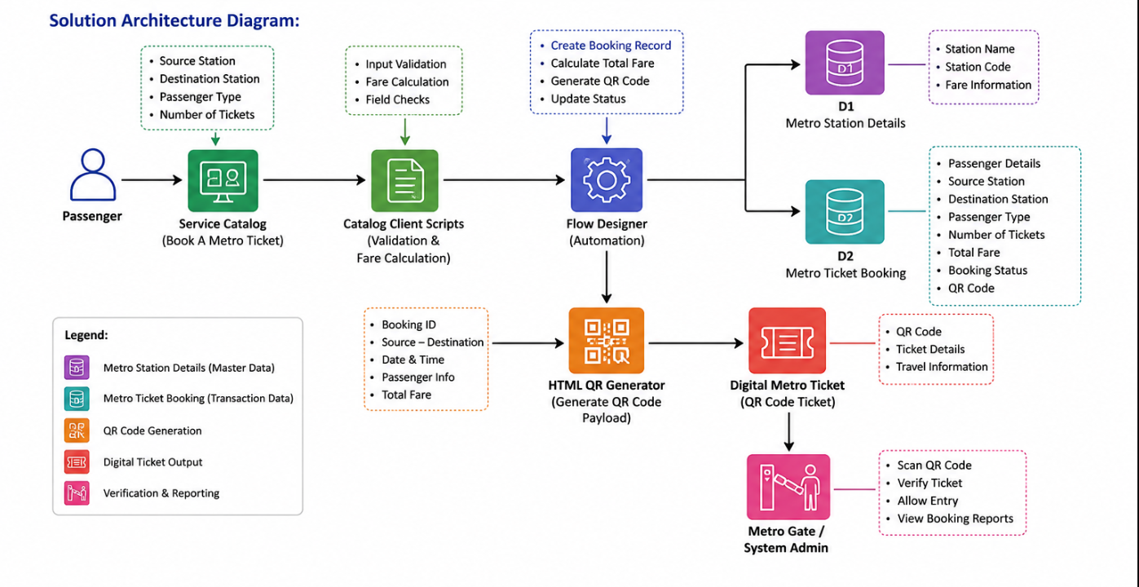
Figure 1: Metro Ticket Booking Architecture Diagram

